**VISVESVARAYA TECHNOLOGICAL UNIVERSITY**

**“JnanaSangama”, Belgaum -590014, Karnataka.**



**LAB REPORT**

**on**

**Big Data Analytics (22CS6PEBDA)**

***Submitted by:***

**Chanchal Bhati(1BM21CS042)**

**Under the Guidance of Prof.**

**Prof. Prameetha Pai**

**Assistant Professor, BMSCE**

***in partial fulfillment for the award of the degree of***

**BACHELOR OF ENGINEERING**

***in***

**COMPUTER SCIENCE AND ENGINEERING**



**B.M.S. COLLEGE OF ENGINEERING**

**(Autonomous Institution under VTU)**

**BENGALURU-560019**

**March 2024 - June 2024**

**B. M. S. College of Engineering,**

**Bull Temple Road, Bangalore 560019**

(Affiliated To Visvesvaraya Technological University, Belgaum) **Department of Computer Science and Engineering**



**CERTIFICATE**

This is to certify that the Lab work entitled “**Big Data Analytics**” carried out by **Chanchal Bhati (1BM21CS042),** who is bonafide student of **B. M. S. College of Engineering.** It is in partial fulfillment for the award of **Bachelor of Engineering in Computer Science and Engineering** of the Visvesvaraya Technological University, Belgaum during the year 2024. The Lab report has been approved as it satisfies the academic requirements in respect of **Big Data**

**Analytics - (22CS6PEBDA)** work prescribed for the said degree.

|  |  |
| --- | --- |
| **Prof. Prameetha Pai** | **Dr. Jyothi S Nayak** |
| Assistant Professor | Professor and Head |
| Department of CSE | Department of CSE |
| BMSCE, Bengaluru | BMSCE, Bengaluru |

**Table Of Contents**

|  |  |  |  |  |
| --- | --- | --- | --- | --- |
| **S.No.** | **Experiment Title** | | | **Page No** |
| **1** | **Course Outcomes** | | |  |
| **2** | **Experiments** | | |  |
|  | **2.1** | **Experiment - 1** | | **1** |
| **2.1.1** | **Question:**  **Perform the following DB operations using Cassandra.**   * Create a keyspace by name Employee * Create a column family by name, Employee-Info with attributes Emp_Id Primary Key, Emp_Name, Designation, Date_of_Joining, Salary, Dept_Name * Insert the values into the table in batch * Update Employee name and Department of Emp-Id 121 * Sort the details of Employee records based on salary * Alter the schema of the table Employee_Info to add a column Projects which stores a * set of Projects done by the corresponding Employee. * Update the altered table to add project names. * Create a TTL of 15 seconds to display the values of Employees. |
| **2.1.2** | **Code with Output** |
| **2.2** | **Experiment - 2** | | **5** |
| **2.2.1** | **Question:**  **Perform the following DB operations using Cassandra:**   * Create a keyspace by name Library * Create a column family by name Library-Info with attributes Stud_Id Primary Key, Counter_value of type Counter, Stud_Name, Book-Name, Book-Id, Date_of_issue * Insert the values into the table in batch * Display the details of the table created and increase the value of the counter * Write a query to show that a student with id 112 has taken a book “BDA” 2 times. * Export the created column to a csv file * Import a given csv dataset from local file system into Cassandra column family**.** |
|  |  | **2.2.2** | **Code with Output** |  |
| **2.3** | **Experiment - 3** | | **7** |
| **2.3.1** | **Question:**  MongoDB- CRUD Demonstration. |

|  |  |  |  |  |
| --- | --- | --- | --- | --- |
|  |  | **2.3.2** | **Code with Output** |  |
| **2.4** | **Experiment - 4** | | **10** |
| **2.4.1** | **Question:**  Hadoop Installation Screenshot |
| **2.4.2** | **Screenshot** |
| **2.5** | **Experiment - 5** | | **12** |
|  | **Question:** |
|  |  | **2.5.1** | Execution of HDFS Commands for interaction with Hadoop Environment. (Minimum 10 commands to be  executed) |  |
| **2.5.2** | **Code with Output** |
| **2.6** | **Experiment - 6** | | **17** |
| **2.6.1** | **Question:**  Implement WordCount Program on Hadoop framework. |
| **2.6.2** | **Code with Output** |
| **2.7** | **Experiment - 7** | | **21** |
| **2.7.1** | **Question:**  **From the following link extract the weather data:**  https://github.com/tomwhite/hadoop- book/tree/master/input/ncdc/all **Create a Map Reduce program to:**   1. Find average temperature for each year from NCDC data set. 2. Find the mean max temperature for every month. |
| **2.7.2** | **Code with Output** |
| **2.8** | **Experiment - 8** | | **24** |
| **2.8.1** | **Question:**  For a given Text file, Create a Map Reduce program to sort the content in an alphabetic order listing only top 10 maximum occurrences of words. |

|  |  |  |  |  |
| --- | --- | --- | --- | --- |
|  |  | **2.8.2** | **Code with Output** |  |

# Course Outcomes

**CO1:** Apply the concepts of NoSQL, Hadoop, Spark for a given task **CO2:** Analyse data analytic techniques for a given problem .

**CO3:** Conduct experiments using data analytics mechanisms for a given problem.

# Experiments 2.1 Experiment - 1

**2.1.1 Question:**  **Perform the following DB operations using Cassandra.**

* Create a keyspace by name Employee
* Create a column family by name, Employee-Info with attributes Emp_Id Primary Key, Emp_Name, Designation, Date_of_Joining, Salary, Dept_Name
* Insert the values into the table in batch
* Update Employee name and Department of Emp-Id 121
* Sort the details of Employee records based on salary
* Alter the schema of the table Employee_Info to add a column Projects which stores a ●  set of Projects done by the corresponding Employee.
* Update the altered table to add project names.
* Create a TTL of 15 seconds to display the values of Employees.

**2.1.2 Code with Output:**

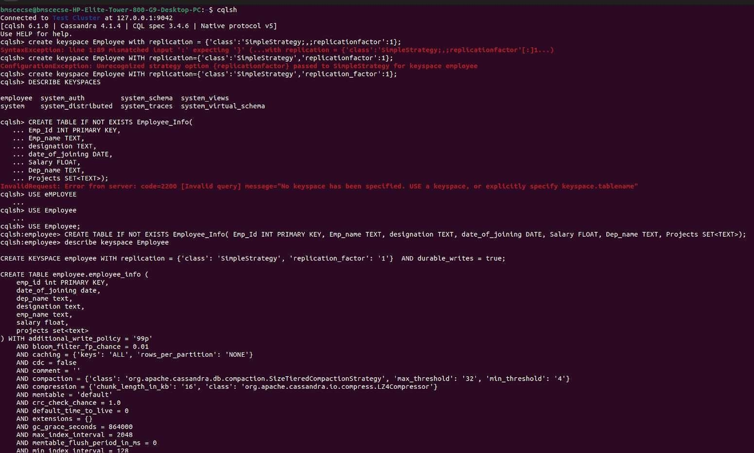

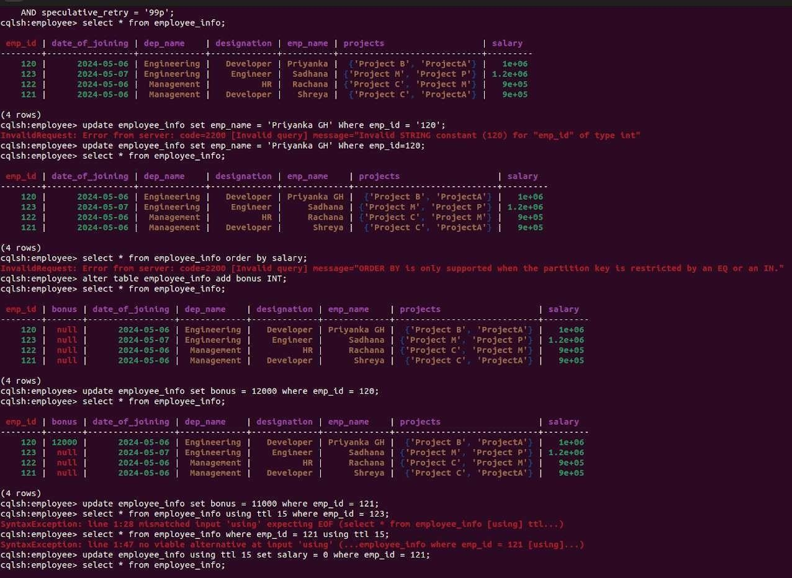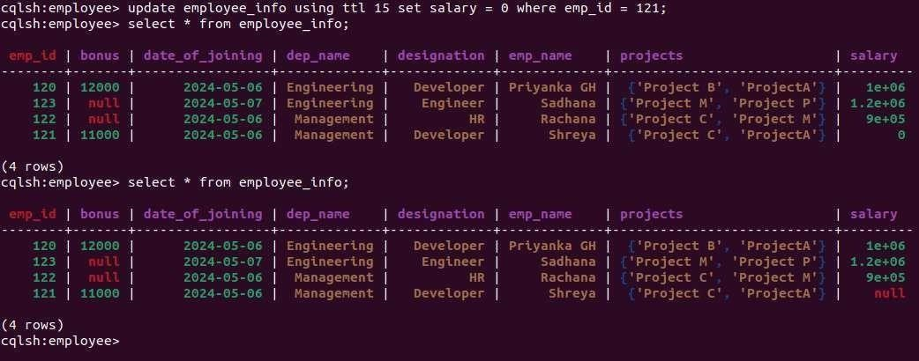

## Experiment - 2

**2.2.1 Question:**  **Perform the following DB operations using Cassandra:**

* Create a keyspace by name Library
* Create a column family by name Library-Info with attributes Stud_Id Primary Key, Counter_value of type Counter, Stud_Name, Book-Name, Book-Id, Date_of_issue
* Insert the values into the table in batch
* Display the details of the table created and increase the value of the counter
* Write a query to show that a student with id 112 has taken a book “BDA” 2 times.
* Export the created column to a csv file
* Import a given csv dataset from local file system into Cassandra column family**.**

**2.2.2 Code with Output:**

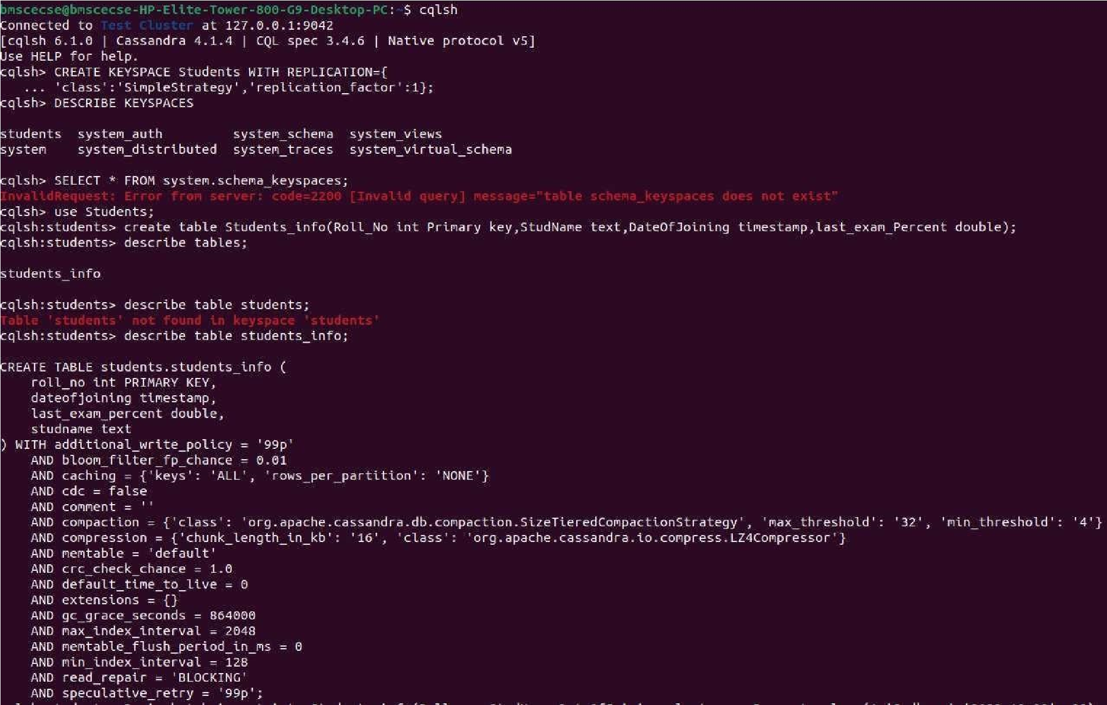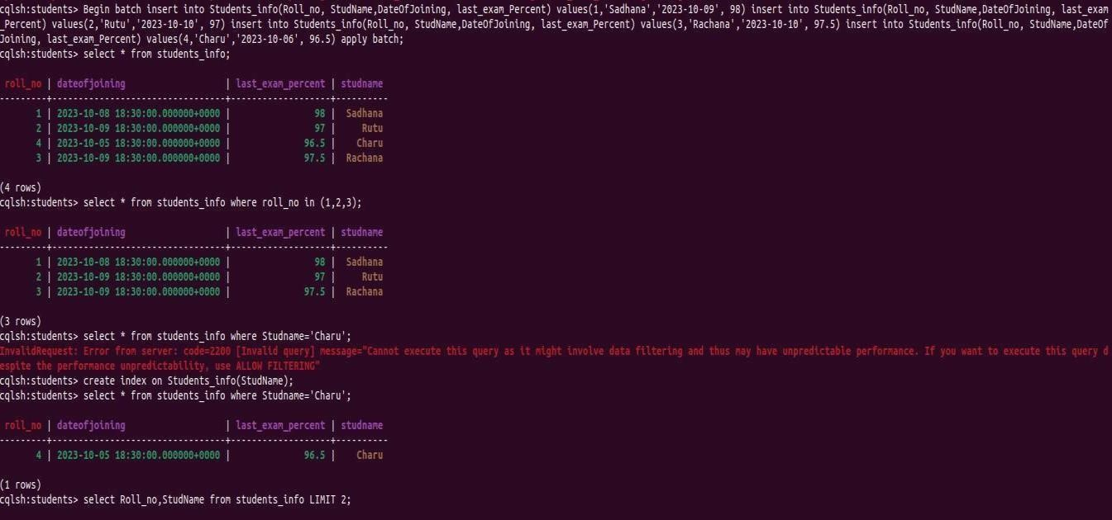

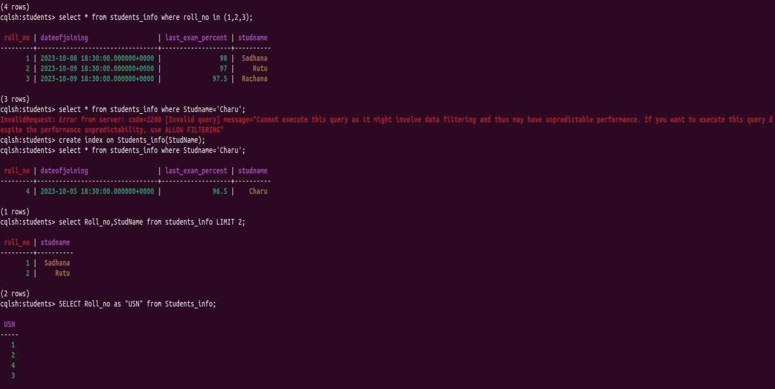

## Experiment - 3

**2.3.1 Question:**  MongoDB - CRUD Demonstration.

**2.3.2 Code with Output:**

1. **Create a database “Student” with the following attributes Rollno, Name , Age, ContactNo, Email-Id, grade, hobby:**

use Students

1. **Insert 5 appropriate values according to the below queries.**

db.students.insertMany([

{ "Rollno": 10, "Name": "John", "Age": 20, "ContactNo": "1234567890", "Email-Id":

"john@example.com", "grade": "A", "hobby": "Reading" },

{ "Rollno": 11, "Name": "Alice", "Age": 21, "ContactNo": "9876543210", "Email-Id":

"alice@example.com", "grade": "B", "hobby": "Painting" },

{ "Rollno": 12, "Name": "Bob", "Age": 22, "ContactNo": "2345678901", "Email-Id":

"bob@example.com", "grade": "C", "hobby": "Cooking" },

{ "Rollno": 13, "Name": "Eve", "Age": 23, "ContactNo": "3456789012", "Email-Id":

"eve@example.com", "grade": "A" },

{ "Rollno": 14, "Name": "Charlie", "Age": 24, "ContactNo": "4567890123", "Email-Id":

"charlie@example.com", "hobby": "Gardening" }

])

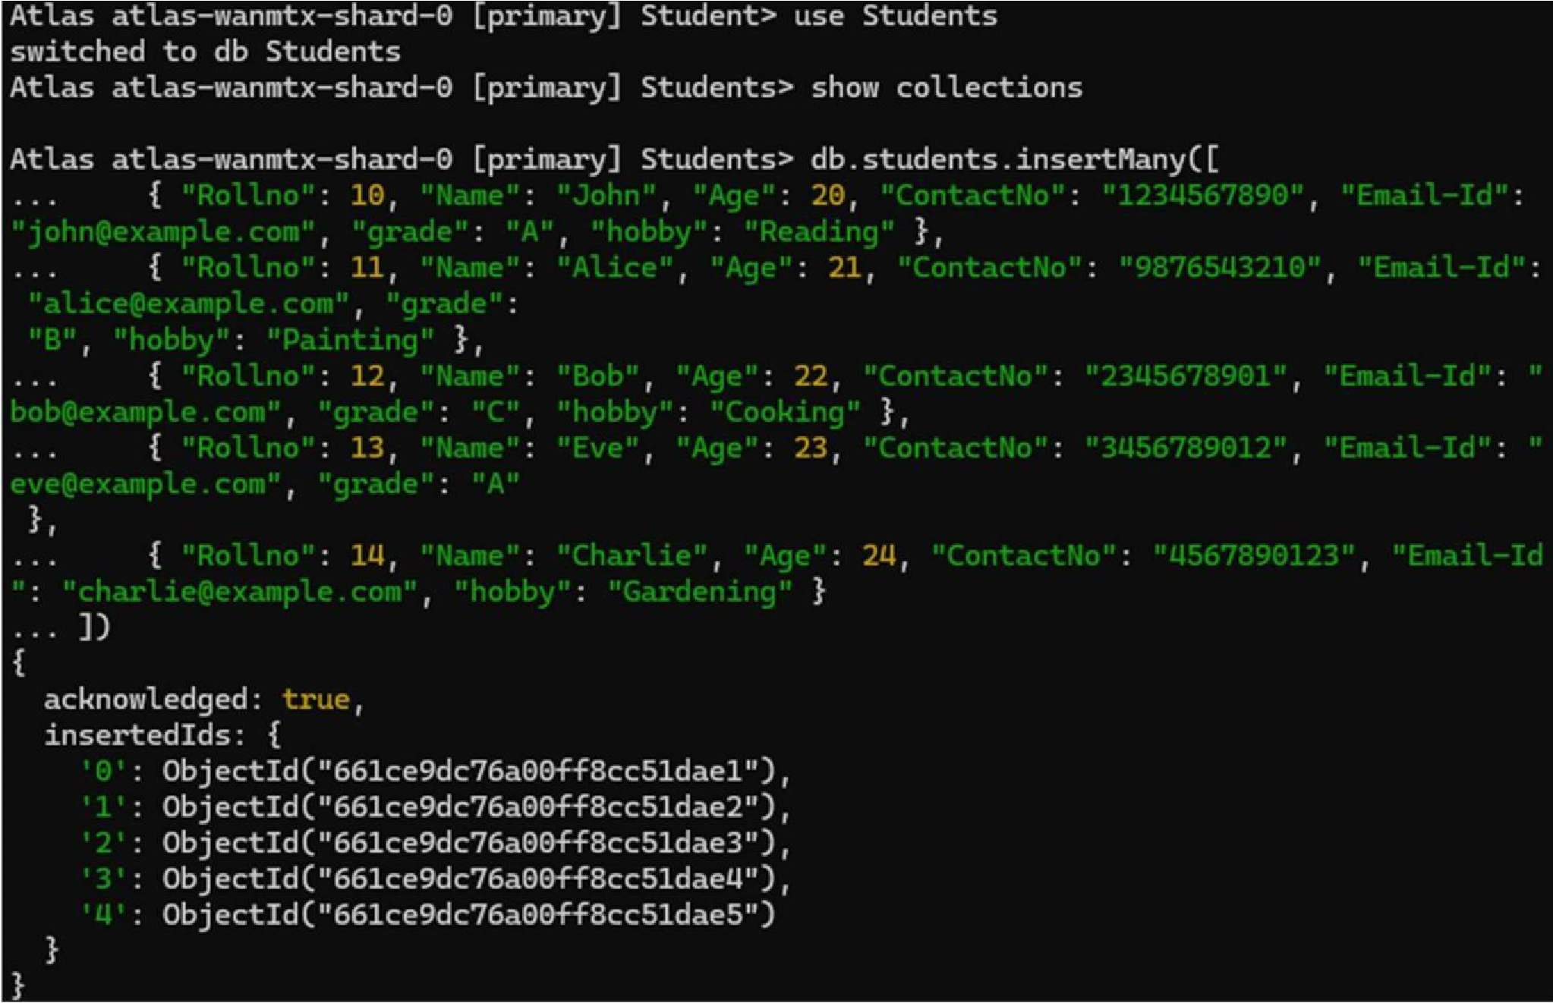

1. **Write query to update Email-Id of a student with rollno 10.** db.students.updateOne(

{ "Rollno": 10 },

{ $set: { "Email-Id": "john.doe@example.com" } }

)

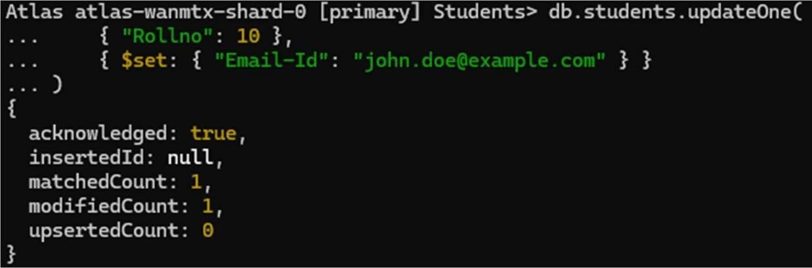

1. **Replace the student name from “Alice” to “Alicee” of rollno 11** db.students.updateOne(

{ "Rollno": 11 },

{ $set: { "Name": "Alicee" } }

)

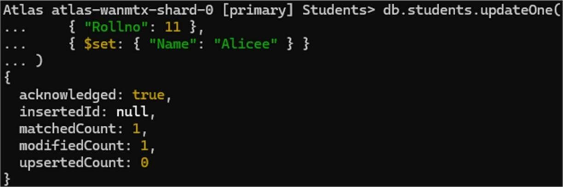

1. **Display Student Name and grade(Add if grade is not present)where the _id column is 1.**  db.students.find({}, { "Name": 1, "grade": { $ifNull: ["$grade", "Not available"] }, "_id": 0 })

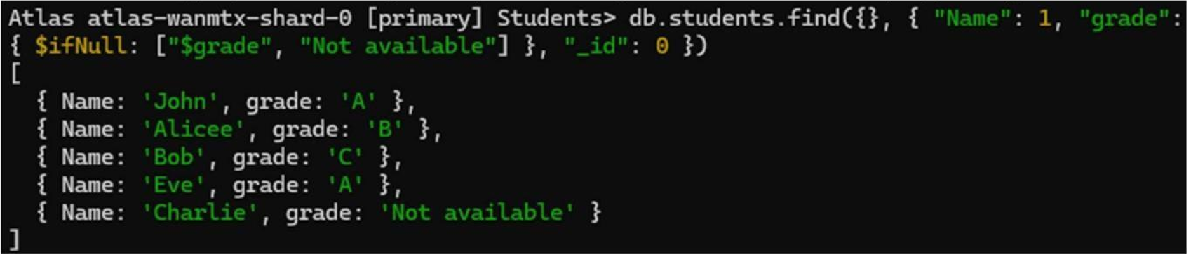

1. **Update to add hobbies** db.students.updateMany(

{ "Name": "Eve" },

{ $set: { "hobby": "Dancing" } }

)

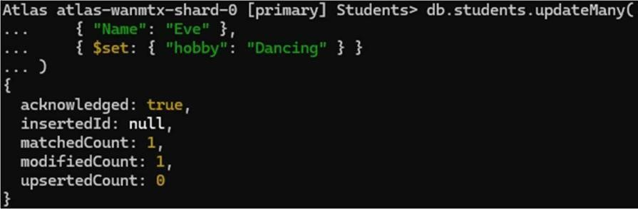

1. **Find documents where hobbies is set neither to Chess nor to Skating** db.students.find({ "hobby": { $nin: ["Chess", "Skating"] } })

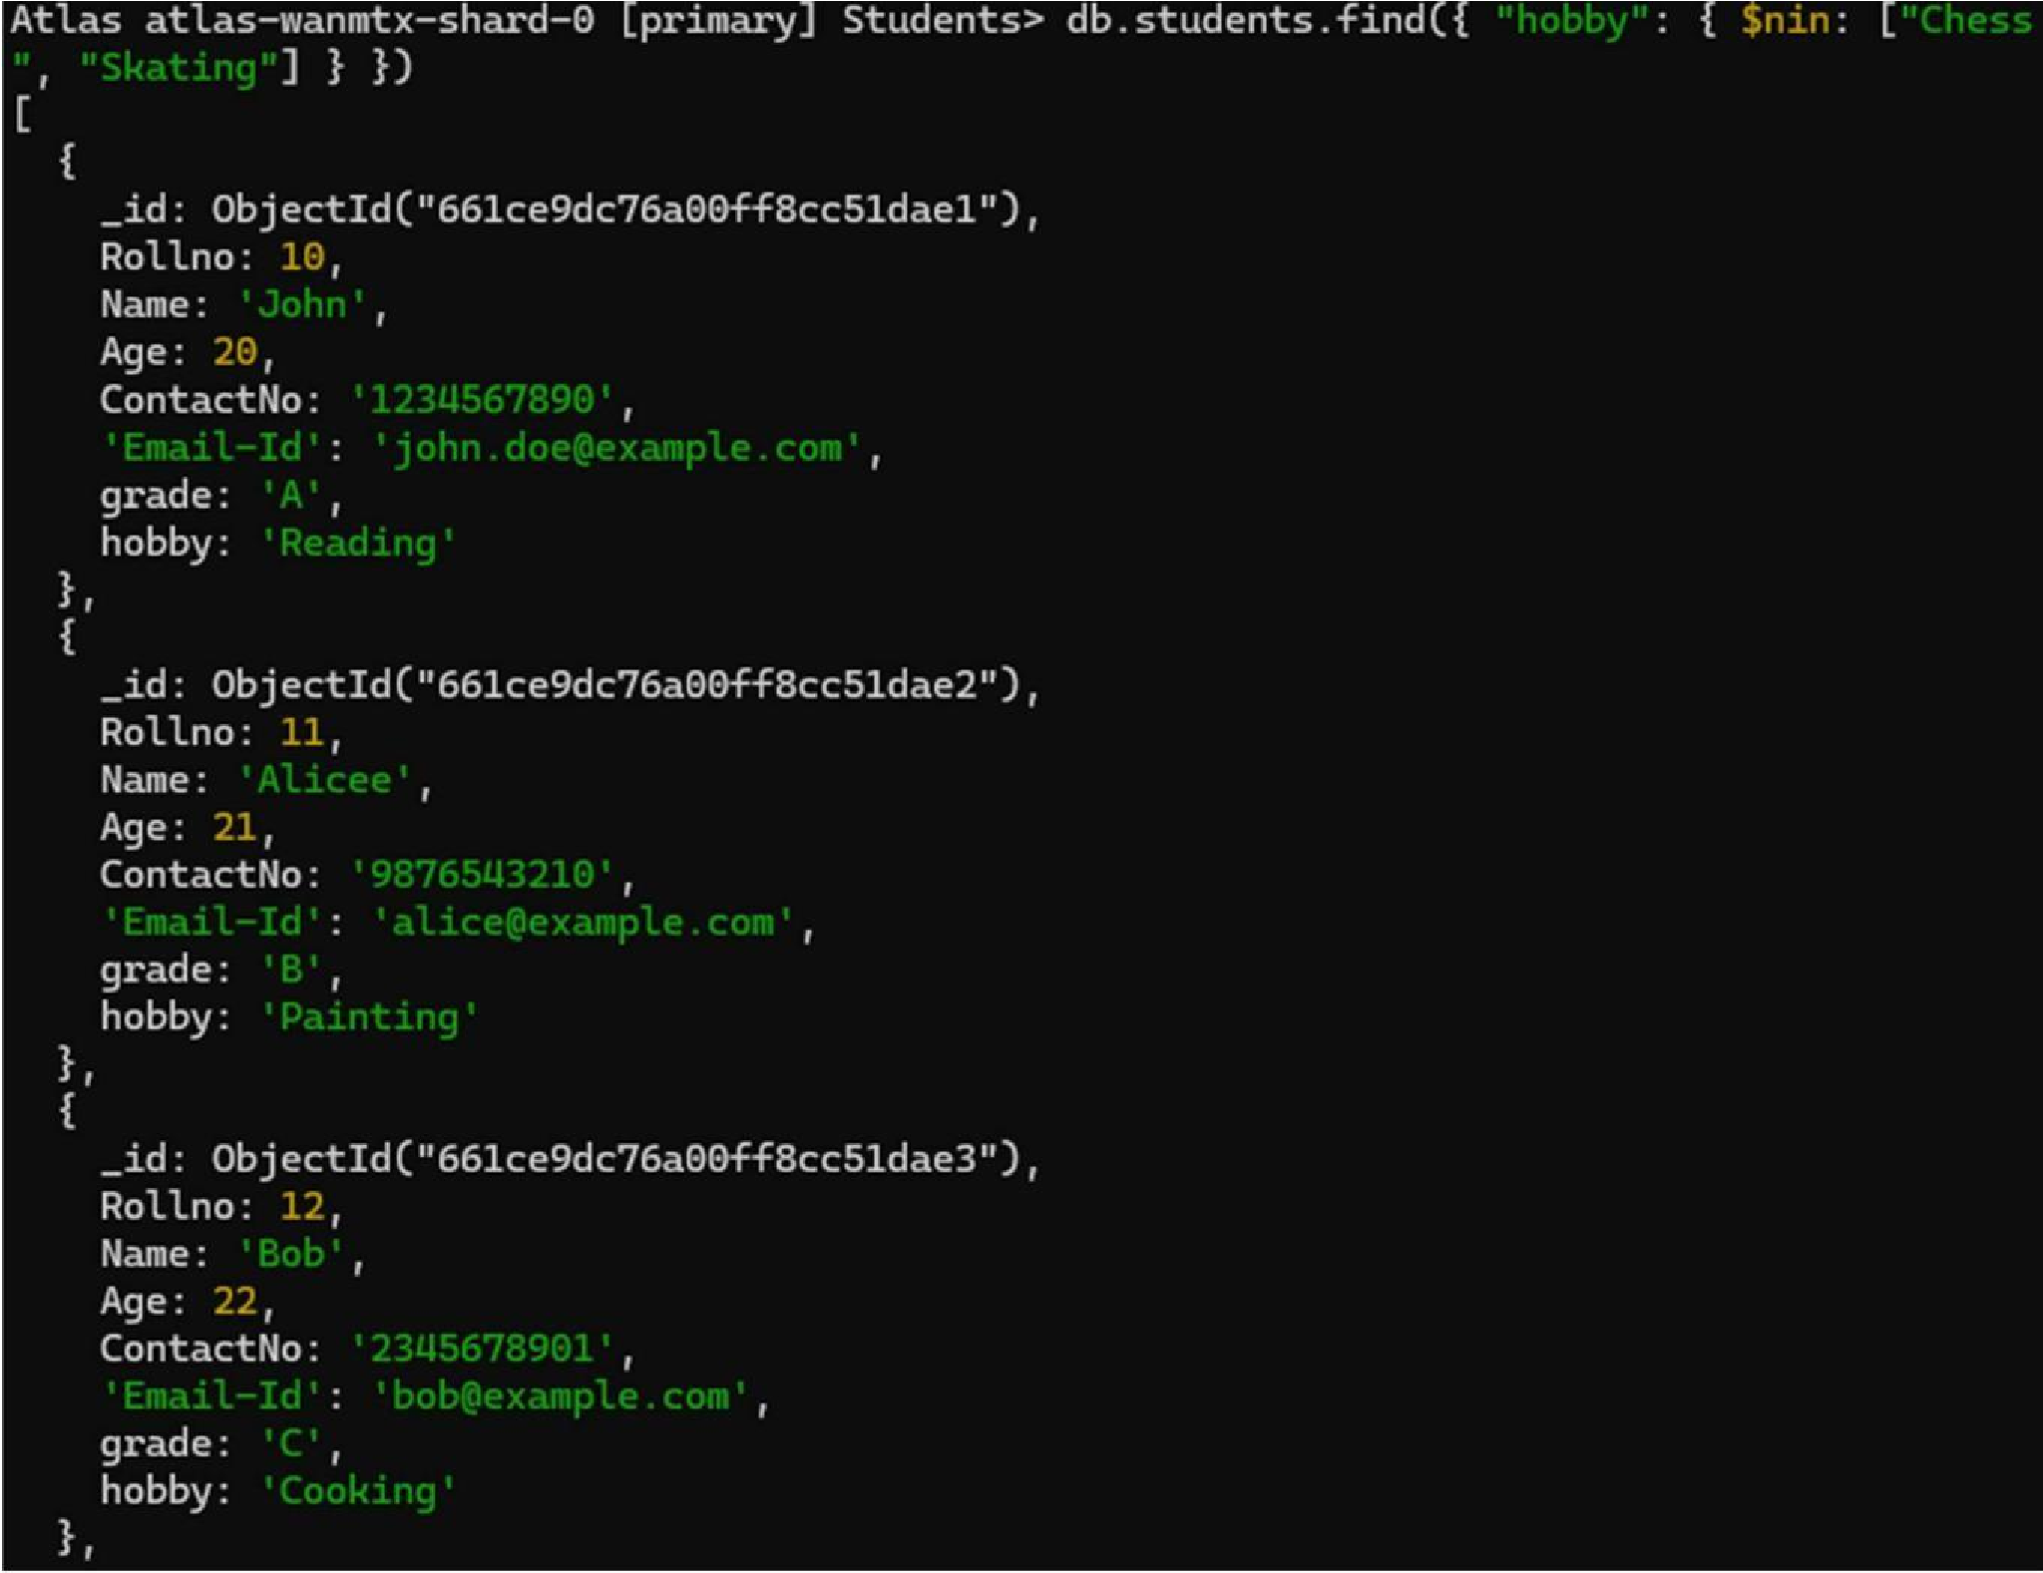

1. **Find documents whose name begins with A** db.students.find({ "Name": /^A/ })

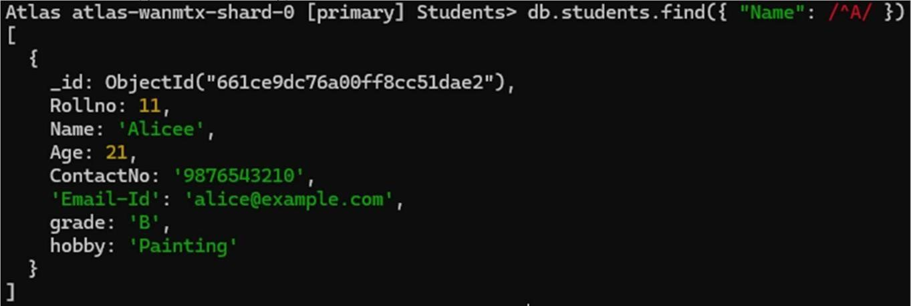

## Experiment - 4

**2.4.1 Question:**

Hadoop Installation Screenshot

**2.4.2 Screenshot:**

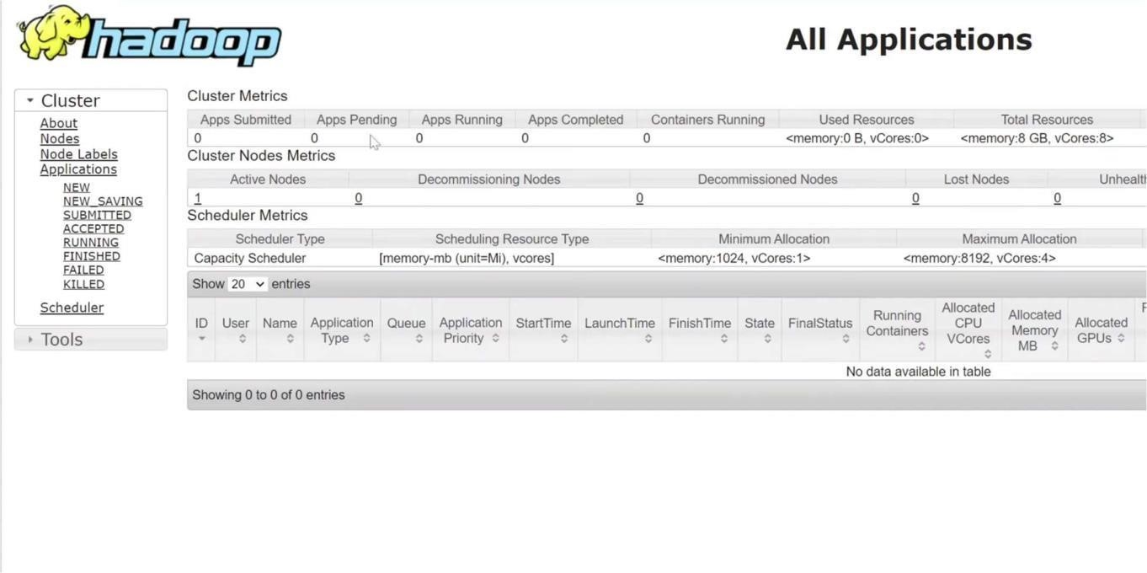

## 5

**2.5.1**

Execution of HDFS Commands for interaction with Hadoop Environment. (Minimum 10 commands to be executed)

**2.5.2 Code with Output:**

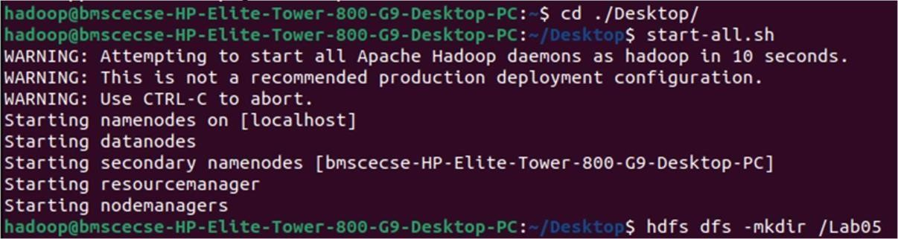



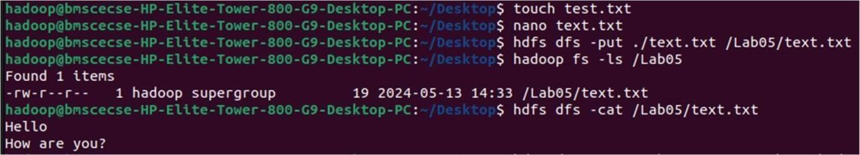

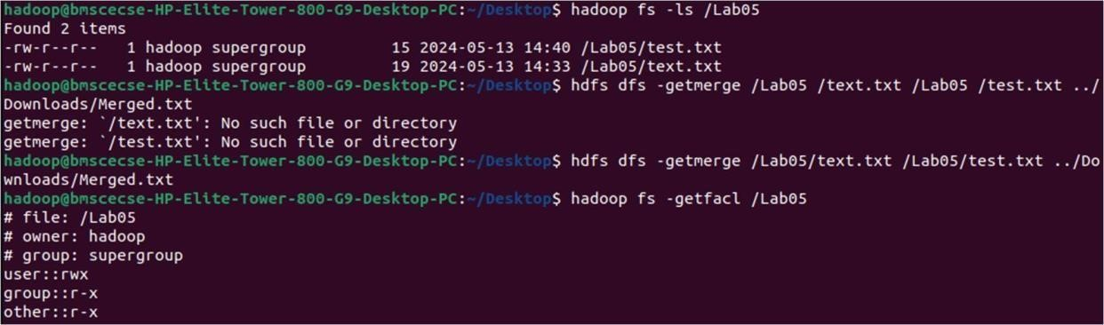





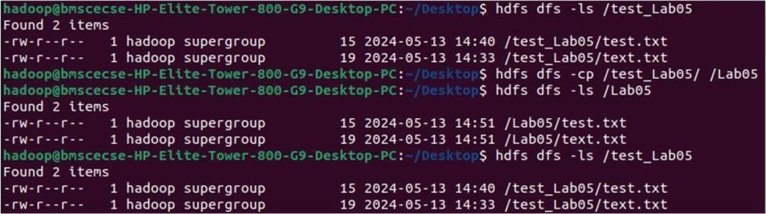

**`**

## 6

**2.6.1** Implement WordCount Program on Hadoop framework.

**2.6.2 Code with Output: Mapper Code:**

import java.io.IOException; import org.apache.hadoop.io.IntWritable; import org.apache.hadoop.io.LongWritable; import org.apache.hadoop.io.Text;

import org.apache.hadoop.mapred.MapReduceBase; import org.apache.hadoop.mapred.Mapper; import org.apache.hadoop.mapred.OutputCollector; import org.apache.hadoop.mapred.Reporter;

public class WCMapper extends MapReduceBase implements Mapper<LongWritable,Text, Text, IntWritable>

{

public void map(LongWritable key, Text value, OutputCollector<Text, IntWritable> output, Reporter rep)

throws IOException

{

String line = value.toString(); for

(String word : line.split(" "))

{ if (word.length() > 0)

{ output.collect(new Text(word), new IntWritable(1)); } } } }

**Reducer Code:**

// Importing libraries import java.io.IOException; import java.util.Iterator; import org.apache.hadoop.io.IntWritable; import org.apache.hadoop.io.Text; import org.apache.hadoop.mapred.MapReduceBase; import org.apache.hadoop.mapred.OutputCollector; import org.apache.hadoop.mapred.Reducer; import

org.apache.hadoop.mapred.Reporter;

public class WCReducer extends MapReduceBase implements Reducer<Text,IntWritable, Text, IntWritable> { // Reduce function public void reduce(Text key, Iterator<IntWritable> value,

OutputCollector<Text, IntWritable> output,

Reporter rep) throws IOException

{ int count = 0;

// Counting the frequency of each words while

(value.hasNext())

{

IntWritable i = value.next(); count

+= i.get();

}

|  |  |  |
| --- | --- | --- |
| output.collect(key, new IntWritable(count)); } } |  |  |
| **Driver Code: WCDriver Java Class** | **file.** | import |
| java.io.IOException; |  | import |
| org.apache.hadoop.conf.Configured; |  | import |
| org.apache.hadoop.fs.Path; |  | import |
| org.apache.hadoop.io.IntWritable; |  | import |
| org.apache.hadoop.io.Text; |  | import |
| org.apache.hadoop.mapred.FileInputFormat; |  | import |
| org.apache.hadoop.mapred.FileOutputFormat; |  | import |
| org.apache.hadoop.mapred.JobClient; |  | import |
| org.apache.hadoop.mapred.JobConf; |  | import |
| org.apache.hadoop.util.Tool; |  | import |

org.apache.hadoop.util.ToolRunner; public class WCDriver extends Configured implements Tool { public int run(String args[]) throws IOException

{

if (args.length < 2)

{

System.out.println("Please give valid inputs");

return -1;

}

JobConf conf = new JobConf(WCDriver.class);

FileInputFormat.setInputPaths(conf, new Path(args[0])); FileOutputFormat.setOutputPath(conf, new Path(args[1]));

conf.setMapperClass(WCMapper.class); conf.setReducerClass(WCReducer.class); conf.setMapOutputKeyClass(Text.class); conf.setMapOutputValueClass(IntWritable.class); conf.setOutputKeyClass(Text.class); conf.setOutputValueClass(IntWritable.class);

JobClient.runJob(conf) ; return 0; } public static void main(String args[]) throws Exception

{

int exitCode = ToolRunner.run(new WCDriver(), args);

System.out.println(exitCode);

}

}

## 7

**2.7.1** **From the following link extract the weather data:**  https://github.com/tomwhite/hadoop-book/tree/master/input/ncdc/all

**Create a Map Reduce program to:**

1. Find average temperature for each year from NCDC data set.
2. Find the mean max temperature for every month.

**2.7.2 Code with Output:**

**a) Find average temperature for each year from NCDC data set.**  **AverageDriver:** package temp;

import org.apache.hadoop.fs.Path; import org.apache.hadoop.io.IntWritable; import org.apache.hadoop.io.Text; import org.apache.hadoop.mapreduce.Job; import org.apache.hadoop.mapreduce.lib.input.FileInputFormat; import org.apache.hadoop.mapreduce.lib.output.FileOutputFormat; public class AverageDriver {

public static void main(String[] args) throws Exception { if (args.length != 2) {

System.err.println("Please Enter the input and output parameters");

System.exit(-1);

}

Job job = new Job(); job.setJarByClass(AverageDriver.class); job.setJobName("Max temperature");

FileInputFormat.addInputPath(job, new Path(args[0])); FileOutputFormat.setOutputPath(job, new Path(args[1])); job.setMapperClass(AverageMapper.class); job.setReducerClass(AverageReducer.class); job.setOutputKeyClass(Text.class); job.setOutputValueClass(IntWritable.class); System.exit(job.waitForCompletion(true) ? 0 : 1);

}

}

**AverageMapper:** package temp; import java.io.IOException; import org.apache.hadoop.io.IntWritable; import org.apache.hadoop.io.LongWritable; import org.apache.hadoop.io.Text; import

org.apache.hadoop.mapreduce.Mapper;

public class AverageMapper extends Mapper<LongWritable, Text, Text, IntWritable> { public static final int MISSING = 9999; public void map(LongWritable key, Text value,

Mapper<LongWritable, Text, Text, IntWritable>.Context context) throws IOException, InterruptedException { int temperature; String line = value.toString(); String year = line.substring(15, 19); if (line.charAt(87) == '+') { temperature =

Integer.parseInt(line.substring(88,

92)); } else { temperature = Integer.parseInt(line.substring(87, 92)); } String quality = line.substring(92, 93); if (temperature != 9999 && quality.matches("[01459]")) context.write(new Text(year), new IntWritable(temperature));

}

}

**AverageReducer:** package temp; import java.io.IOException;

import org.apache.hadoop.io.IntWritable; import org.apache.hadoop.io.Text; import org.apache.hadoop.mapreduce.Reducer; public class AverageReducer extends Reducer<Text, IntWritable, Text, IntWritable> { public void reduce(Text key, Iterable<IntWritable> values, Reducer<Text, IntWritable, Text, IntWritable>.Context context) throws IOException, InterruptedException { int max_temp = 0; int count = 0; for (IntWritable value : values) { max_temp += value.get(); count++;

} context.write(key, new IntWritable(max_temp / count)); }}

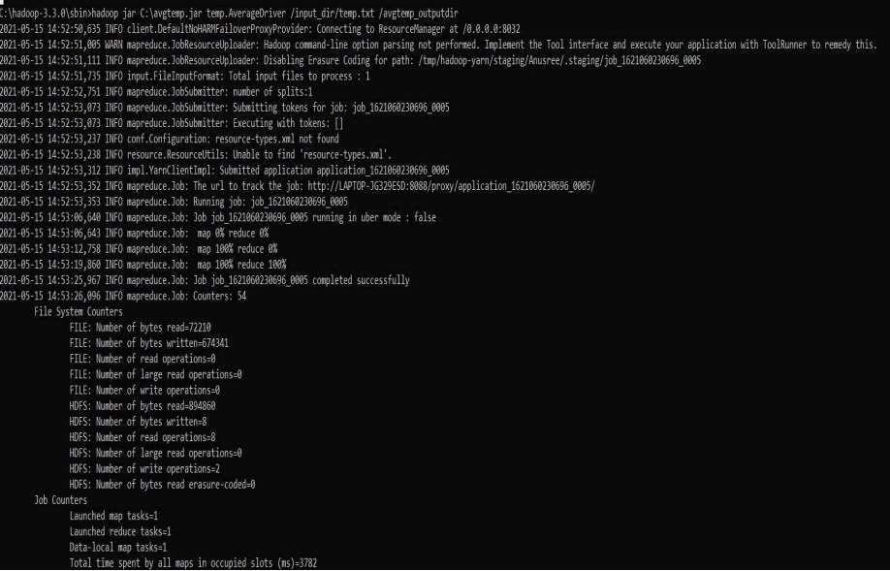

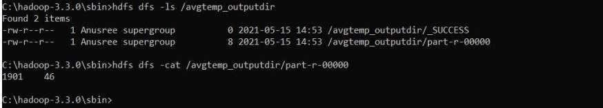

**b) find the mean max temperature for every month MeanMaxDriver.class** package meanmax; import org.apache.hadoop.fs.Path; import org.apache.hadoop.io.IntWritable; import org.apache.hadoop.io.Text; import org.apache.hadoop.mapreduce.Job;

import org.apache.hadoop.mapreduce.lib.input.FileInputFormat; import

org.apache.hadoop.mapreduce.lib.output.FileOutputFormat; public class MeanMaxDriver {

public static void main(String[] args) throws Exception { if (args.length != 2) {

System.err.println("Please Enter the input and output parameters"); System.exit(-1);

}

Job job = new Job(); job.setJarByClass(MeanMaxDriver.class); job.setJobName("Max temperature");

FileInputFormat.addInputPath(job, new Path(args[0])); FileOutputFormat.setOutputPath(job, new Path(args[1]));

job.setMapperClass(MeanMaxMapper.class); job.setReducerClass(MeanMaxReducer.class); job.setOutputKeyClass(Text.class); job.setOutputValueClass(IntWritable.class); System.exit(job.waitForCompletion(true) ? 0 : 1);

}

}

**MeanMaxMapper.class** package meanmax; import java.io.IOException; import org.apache.hadoop.io.IntWritable; import org.apache.hadoop.io.LongWritable; import org.apache.hadoop.io.Text; import

org.apache.hadoop.mapreduce.Mapper;

public class MeanMaxMapper extends Mapper<LongWritable, Text, Text, IntWritable> { public

static final int MISSING = 9999;

public void map(LongWritable key, Text value, Mapper<LongWritable, Text, Text, IntWritable>.Context context) throws IOException, InterruptedException { int temperature;

String line = value.toString(); String month = line.substring(19, 21); if

(line.charAt(87) == '+') { temperature = Integer.parseInt(line.substring(88, 92));

} else {

temperature = Integer.parseInt(line.substring(87, 92));

}

String quality = line.substring(92, 93);

if (temperature != 9999 && quality.matches("[01459]"))

context.write(new Text(month), new IntWritable(temperature)); }

}

**MeanMaxReducer.class** package meanmax; import java.io.IOException; import org.apache.hadoop.io.IntWritable; import org.apache.hadoop.io.Text; import org.apache.hadoop.mapreduce.Reducer;

public class MeanMaxReducer extends Reducer<Text, IntWritable, Text, IntWritable> { public void reduce(Text key, Iterable<IntWritable> values, Reducer<Text, IntWritable, Text, IntWritable>.Context context) throws IOException, InterruptedException { int max_temp = 0; int total_temp = 0; int count = 0; int days = 0;

for (IntWritable value : values) { int temp = value.get(); if (temp > max_temp) max_temp = temp; count++; if (count == 3) { total_temp += max_temp; max_temp = 0; count = 0; days++;

}

} context.write(key, new IntWritable(total_temp / days));

}

}

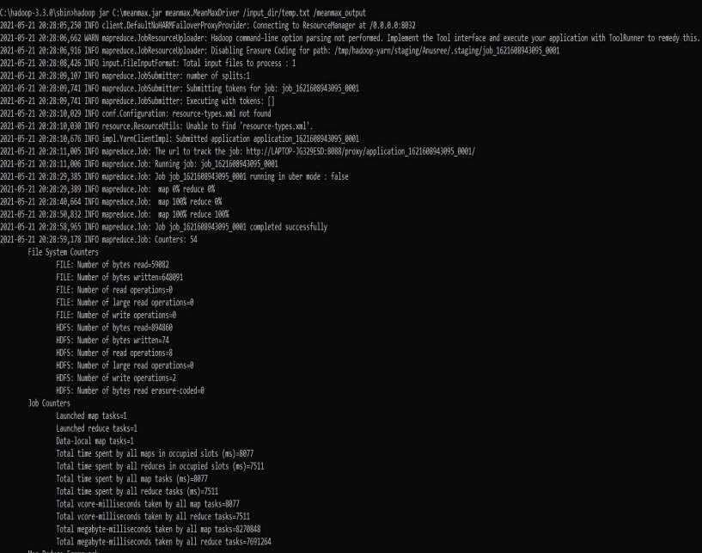

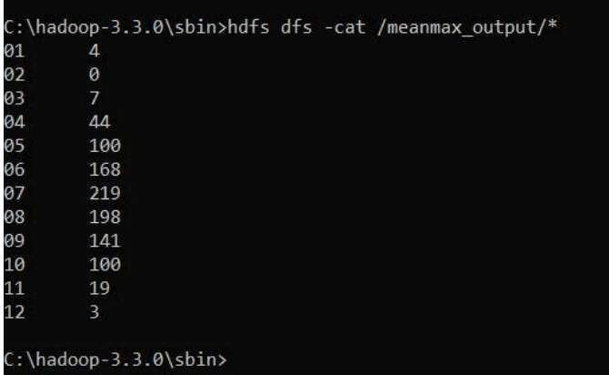

## Experiment - 8

**2.8.1 Question:**

For a given Text file, Create a Map Reduce program to sort the content in an alphabetic order listing only top 10 maximum occurrences of words.

**2.8.2 Code with Output: Driver-**

**TopN.class** package samples.topn; import java.io.IOException; import java.util.StringTokenizer; import org.apache.hadoop.conf.Configuration; import org.apache.hadoop.fs.Path; import org.apache.hadoop.io.IntWritable; import org.apache.hadoop.io.Text; import org.apache.hadoop.mapreduce.Job; import org.apache.hadoop.mapreduce.Mapper;

import org.apache.hadoop.mapreduce.lib.input.FileInputFormat; import org.apache.hadoop.mapreduce.lib.output.FileOutputFormat; import org.apache.hadoop.util.GenericOptionsParser; public class TopN { public static void main(String[] args) throws Exception {

Configuration conf = new Configuration();

String[] otherArgs = (new GenericOptionsParser(conf, args)).getRemainingArgs(); if (otherArgs.length != 2) {

System.err.println("Usage: TopN <in> <out>");

System.exit(2);

}

Job job = Job.getInstance(conf); job.setJobName("Top N"); job.setJarByClass(TopN.class); job.setMapperClass(TopNMapper.class); job.setReducerClass(TopNReducer.class); job.setOutputKeyClass(Text.class); job.setOutputValueClass(IntWritable.class);

FileInputFormat.addInputPath(job, new Path(otherArgs[0]));

FileOutputFormat.setOutputPath(job, new Path(otherArgs[1]));

System.exit(job.waitForCompletion(true) ? 0 : 1);

}

public static class TopNMapper extends Mapper<Object, Text, Text, IntWritable> { private static final IntWritable one = new IntWritable(1); private Text word = new Text(); private String tokens = "[_|$#<>\\^=\\[\\]\\*/\\\\,;,.\\-:()?!\"']";

public void map(Object key, Text value, Mapper<Object, Text, Text, IntWritable>.Context context)

throws IOException, InterruptedException {

String cleanLine = value.toString().toLowerCase().replaceAll(this.tokens, " "); StringTokenizer itr = new StringTokenizer(cleanLine); while (itr.hasMoreTokens()) { this.word.set(itr.nextToken().trim()); context.write(this.word, one);

}

}

}

}

**TopNCombiner.class** package samples.topn; import java.io.IOException; import org.apache.hadoop.io.IntWritable; import org.apache.hadoop.io.Text; import org.apache.hadoop.mapreduce.Reducer;

public class TopNCombiner extends Reducer<Text, IntWritable, Text, IntWritable> { public void reduce(Text key, Iterable<IntWritable> values, Reducer<Text, IntWritable, Text, IntWritable>.Context context) throws IOException, InterruptedException { int sum = 0;

for (IntWritable val : values) sum

+= val.get(); context.write(key, new IntWritable(sum));

}

}

**TopNMapper.class** package samples.topn; import java.io.IOException; import java.util.StringTokenizer; import org.apache.hadoop.io.IntWritable; import org.apache.hadoop.io.Text; import

org.apache.hadoop.mapreduce.Mapper;

public class TopNMapper extends Mapper<Object, Text, Text, IntWritable> { private static final IntWritable one = new IntWritable(1); private Text word = new Text(); private String tokens = "[_|$#<>\\^=\\[\\]\\*/\\\\,;,.\\-:()?!\"']";

public void map(Object key, Text value, Mapper<Object, Text, Text, IntWritable>.Context context)

throws IOException, InterruptedException {

String cleanLine = value.toString().toLowerCase().replaceAll(this.tokens, " "); StringTokenizer itr = new StringTokenizer(cleanLine); while (itr.hasMoreTokens()) { this.word.set(itr.nextToken().trim()); context.write(this.word, one);

}

}

}

**TopNReducer.class** package samples.topn; import java.io.IOException; import java.util.HashMap; import java.util.Map;

import org.apache.hadoop.io.IntWritable; import org.apache.hadoop.io.Text; import org.apache.hadoop.mapreduce.Reducer;

import utils.MiscUtils;

public class TopNReducer extends Reducer<Text, IntWritable, Text, IntWritable> { private Map<Text, IntWritable> countMap = new HashMap<>(); public void reduce(Text key, Iterable<IntWritable> values, Reducer<Text, IntWritable, Text, IntWritable>.Context context) throws IOException, InterruptedException { int sum = 0; for (IntWritable val : values) sum += val.get();

this.countMap.put(new Text(key), new IntWritable(sum));

}

protected void cleanup(Reducer<Text, IntWritable, Text, IntWritable>.Context context) throws IOException, InterruptedException {

Map<Text, IntWritable> sortedMap = MiscUtils.sortByValues(this.countMap); int counter = 0;

for (Text key : sortedMap.keySet()) {

if (counter++ == 20) break;

context.write(key, sortedMap.get(key));

}

}

}

